AKS Backup

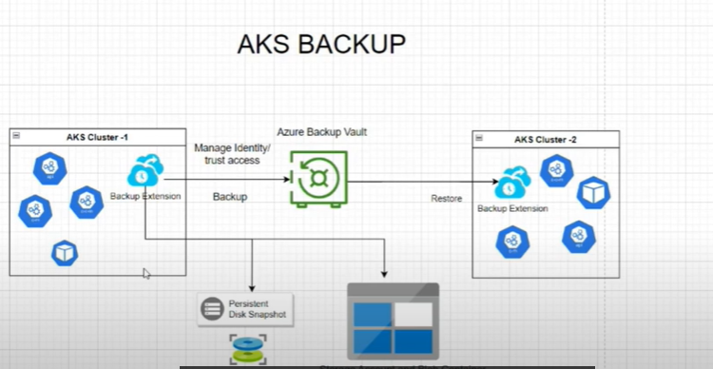

Prerequirment:

1.Backup extension installed in AKS cluster

2.Azure Backup vault

Aks Backup requires Trusted Access to be established between backup vauld and AKS cluster. Trusted Access allows Backup vault to access the AKS cluster with specific permission assigned to it related to the Backup operations

You ca restore the backps to the orginal or an alternative cluster in the same subscrptions and region. The provides flexibility to restore your data in case of disaster recovery or testing purposes